Alerts & API Gateways
Reviewing Alerts concepts

An API alert is an alarm that flags one of the following problems:

- The API request violates a policy
- Requests received by the API exceed a given number within a period of time.
- The API returns a specified HTTP error code.
- The API response time exceeds a certain amount.

Runtime Manager alerts differ in nature from API alerts. Runtime Manager flags CPU usage, secure data gateway up/down, and deployment success/failure, to name a few. API alerts, on the other hand, relate to an API request or response.

You can add one of the following types of alerts to an API:

- Policy violation
An infraction of one or more policies that govern the API occurs.

- Request Count
Users request access to the API more times than allowed in a specified period of time.

- Response Code
The API returns one of these HTTP codes upon receiving a request: 400, 401, 403, 404, 408, 500, 502, or 503

- Response Time
The response time of the API exceeds a specified period.

A request count alert condition is similar to a policy alert that uses the rate limiting policy. Valid entries for the time interval option for a request count are in the range 1 - 999999999. These time intervals specified are implemented as sliding windows, not absolute minute boundaries, to prevent problems caused by data bursts.

You create and configure an API alert by adding alerts to an API instance in API Manager.

Alert Notifications

API Manager fires alerts when condition state changed from good to bad or from bad to good. No new alert fires if the condition remains in the same state. For a newly created alert initial state is undefined, so the very first occurrence of the bad state can be missed.

When the alert fires, API Manager sends email notifications to you, and to others if configured.

When you set an alert, you select users in your Business Group who can receive email notifications about the alert. The notification includes information about events that trigger the alert as specified by the level of severity. Users receive two emails:

- One email describes the alert. For example:
Your API, CesarDemoAPI - Basic:151 (Environment: "NewOne"), has received greater than 2 requests within 1 consecutive periods of 1 minutes.

- Another email notifies you when the alert is resolved.
Your API Version, jsonplaceholderapi - 1.0.development, is no longer in an alert state. The number of policy violations was not greater than 1 in the last 1 consecutive periods of 1 minutes.
After an alert fires, and API Manager sends the first set of two notification emails, and stops listening for alerts until the next alert period begins. This technique prevents repetitive notification emails.

Adding an API Alert

1. In API Manager 2.x, in API Administration, select an API instance, and on the API instance dashboard, select Alerts.

2. Click Add Alert and set the alert options:

- Name: Type an alert name, for example red-alert.
- Enabled: Accept the default, Enabled, for example.
- Severity: Accept the default, Critical.
- Alert type: Select Request Count, for example.
- When number of occurrences are: Select Greater.
- than: Select 1.
- For at least: Select an entry in the range 1 - 999999999 to specify the time intervals as a sliding windows.
- Recipients: Select the names of users in your business group, or type the email addresses, of users who will receive notification when the alert fires. Press RETURN.
3. Create the alert.

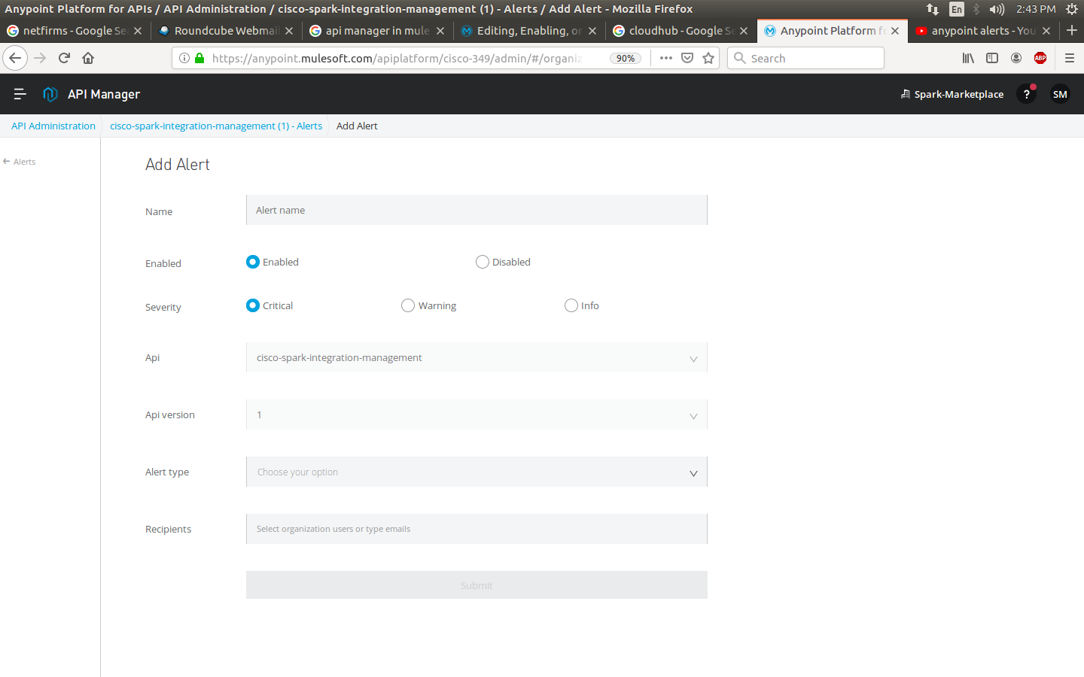

Sample Alerts Types dropdown
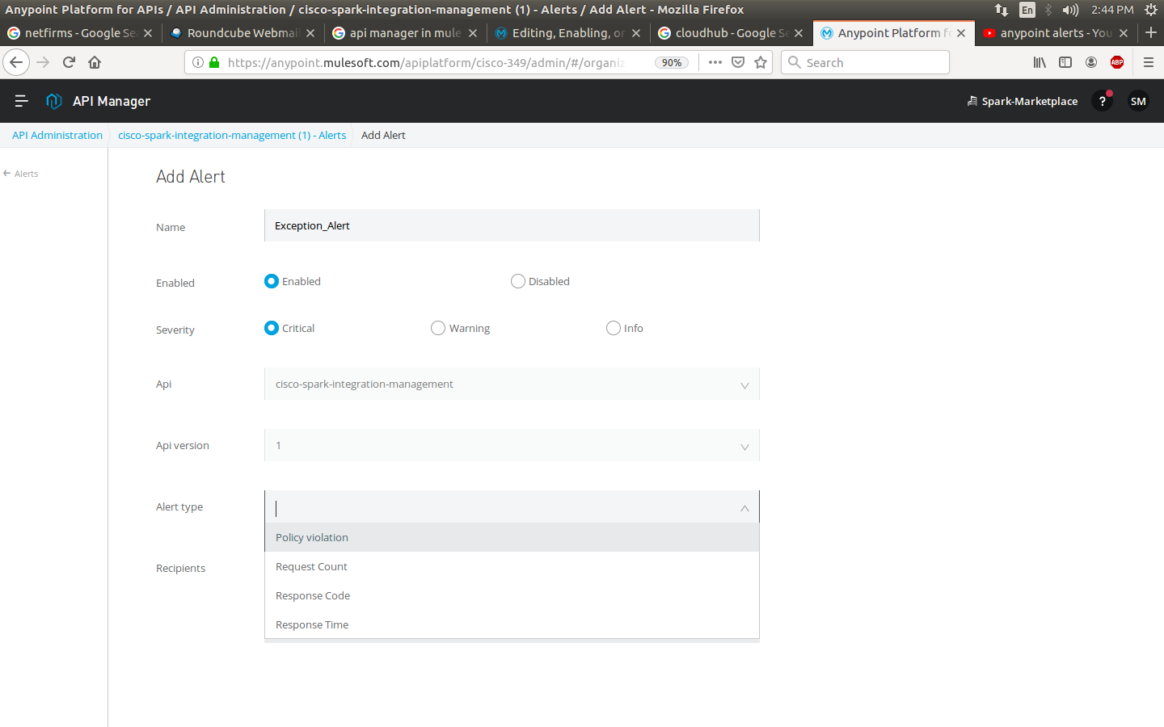

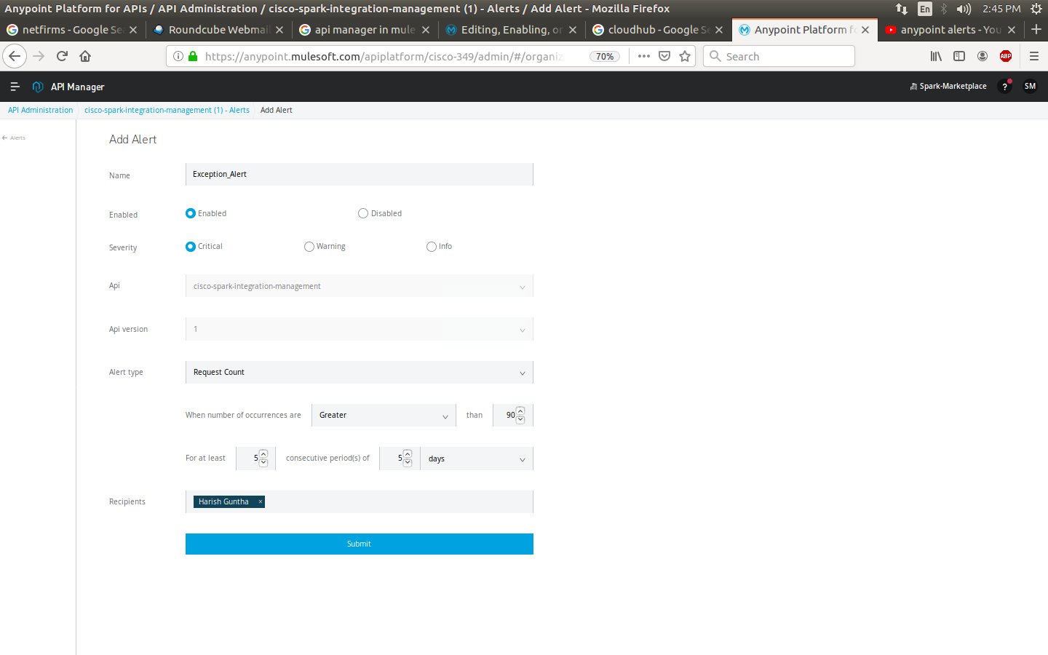
Sample Details Provided

Testing an API Alert

This procedure describes how to test a request count alert. This procedure requires the following preparation:

1. Design an API.
2. Publish the API to Exchange.
3. In API Manager, manage the API from Exchange.
4. Deploy a proxy of the API instance to CloudHub.
5. Apply the Rate Limiting Policy to the API as follows: Request Count greater than 1 for at least 1 consecutive minute.
6. Add the alert described in the topic about how to add an alert.
7. Call the API.
8. Recall the API two more times (reload the page). Check that API calls exceeded appears if you called and recalled the API within the 1 minute period. Any additional page reload operations within the 1 minute period have no effect.
9. Check that users, who you selected for email notification when you added the alert, actually receive email notifications.
10. Check that the alert was resolved.

Viewing and Deleting API Alerts

In the Organization Administrators role for the master organization, you can view a list of alerts.

Note: To view and delete API alerts, users must have Manage Alerts permission. To only view alerts, users must have View Alerts permission. See To Set Permissions.

This procedure describes how to view and delete alerts.

- In API Manager > API Administration, click the API instance, and select Alerts.
new alerts
- Expand an alert in the list.
Details about the alert options appear.
- Click Delete.

Editing, Enabling, or Disabling API Alerts

When creating an alert, you can select if the alert will be enabled or disabled. You can also edit an existing alert and enable or disable the alert.

- In API Manager click API Administration on the left navigation bar.
- Click the API instance, and version that you want to edit and click Alerts.
- Click the Edit button on the alert you want to edit.
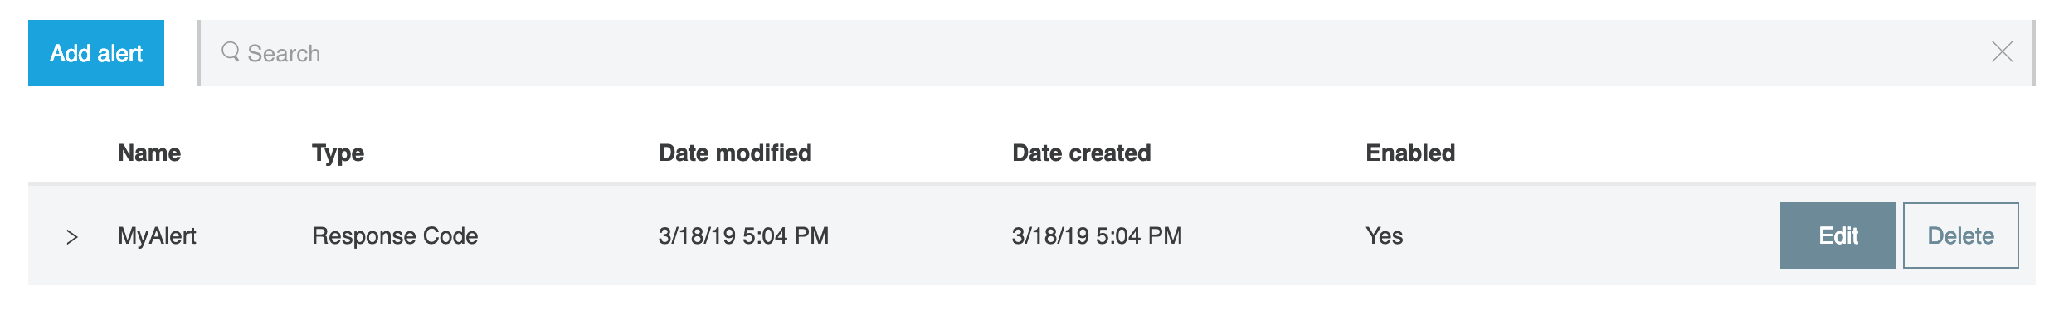

API Gateway capabilities

Mule Runtime includes an embedded API Gateway. Using this gateway, any user can, for example, apply a basic authentication policy on top of a Mule application, enrich an incoming/outgoing message, or add any other complex capability to an API without having to write any code.
Overall, API Gateway allows you to add a dedicated orchestration layer on top of your backend APIs and services to help you separate orchestration from implementation concerns. You can leverage the governance capabilities of API Manager to apply, among other capabilities, throttling, security, caching, and logging to your APIs.

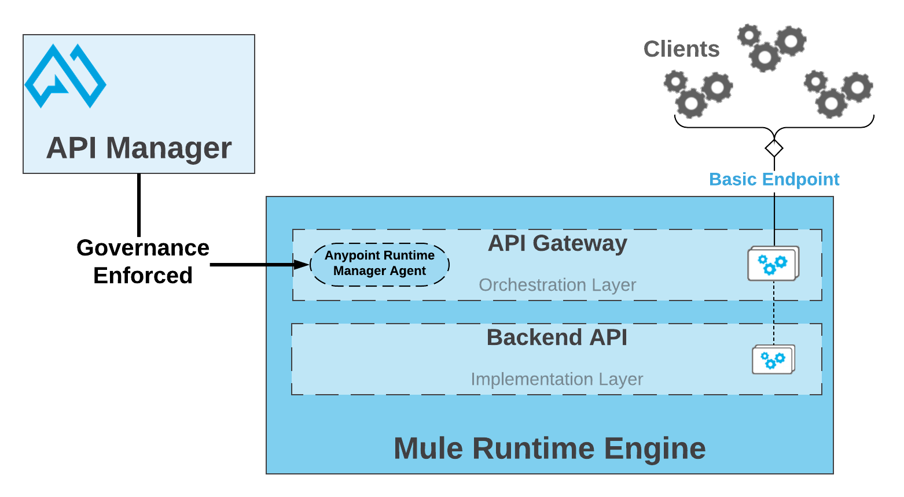

If you want to apply policies and generate analytics info, you must use either:

- An API defined in a Mule application.
- A Mule application that proxies your existing backend implementation.

Key Concepts

API

An API is an abstraction of a set of components. It encapsulates the complexity of your Mule application development, and it presents an easy and reusable way of accessing your assets.
Pairing your API to API Manager through an Autodiscovery element enables you to apply policies to that API.

HTTP/HTTPS API

An API that you create using an HTTP Exchange asset. API Gateway assumes that the associated Mule application being tracked by API Manager has an HTTP or HTTPS listener defined as an implementation endpoint.

Typical usage: REST based APIs.

RAML API

An API that you create using a RAML/OAS Exchange asset. Your API Gateway assumes that the associated Mule application being tracked by API Manager has an HTTP or HTTPS listener with a RAML/OAS router defined as an implementation endpoint.

To make this asset available in Exchange, you can design your API using API Designer and then export it to Exchange.

Typical usage: RAML/OAS based APIs.

WSDL API

An API that you create using a WSDL Exchange asset. Your API Gateway assumes that the associated Mule application being tracked by API Manager has an HTTP or HTTPS listener with a WSDL router defined as an implementation endpoint.

Typical usage: WSDL based APIs.

API Autodiscovery

API Autodiscovery allows API Manager to manage an API that represents an HTTP endpoint of a Mule application.
Essentially, it’s the mechanism that links an HTTP resource to its API definition in API Manager.

Through API Autodiscovery, API Gateway can synchronize the configuration defined in the corresponding paired API from API Manager. For Autodiscovery to work, the Mule Runtime that is acting as a gateway requires Anypoint Platform organization credentials.

API Proxy

API proxies, also known as "autogenerated proxies", are meant to enhance the usability of API Manager in your Mule application.

Typical usage: Either when you want to leverage API Gateway capabilities and your backend API is not based on Mule Runtime, or when your API is based on Mule Runtime but you are unable to define the corresponding Autodiscovery element because it is a closed code.

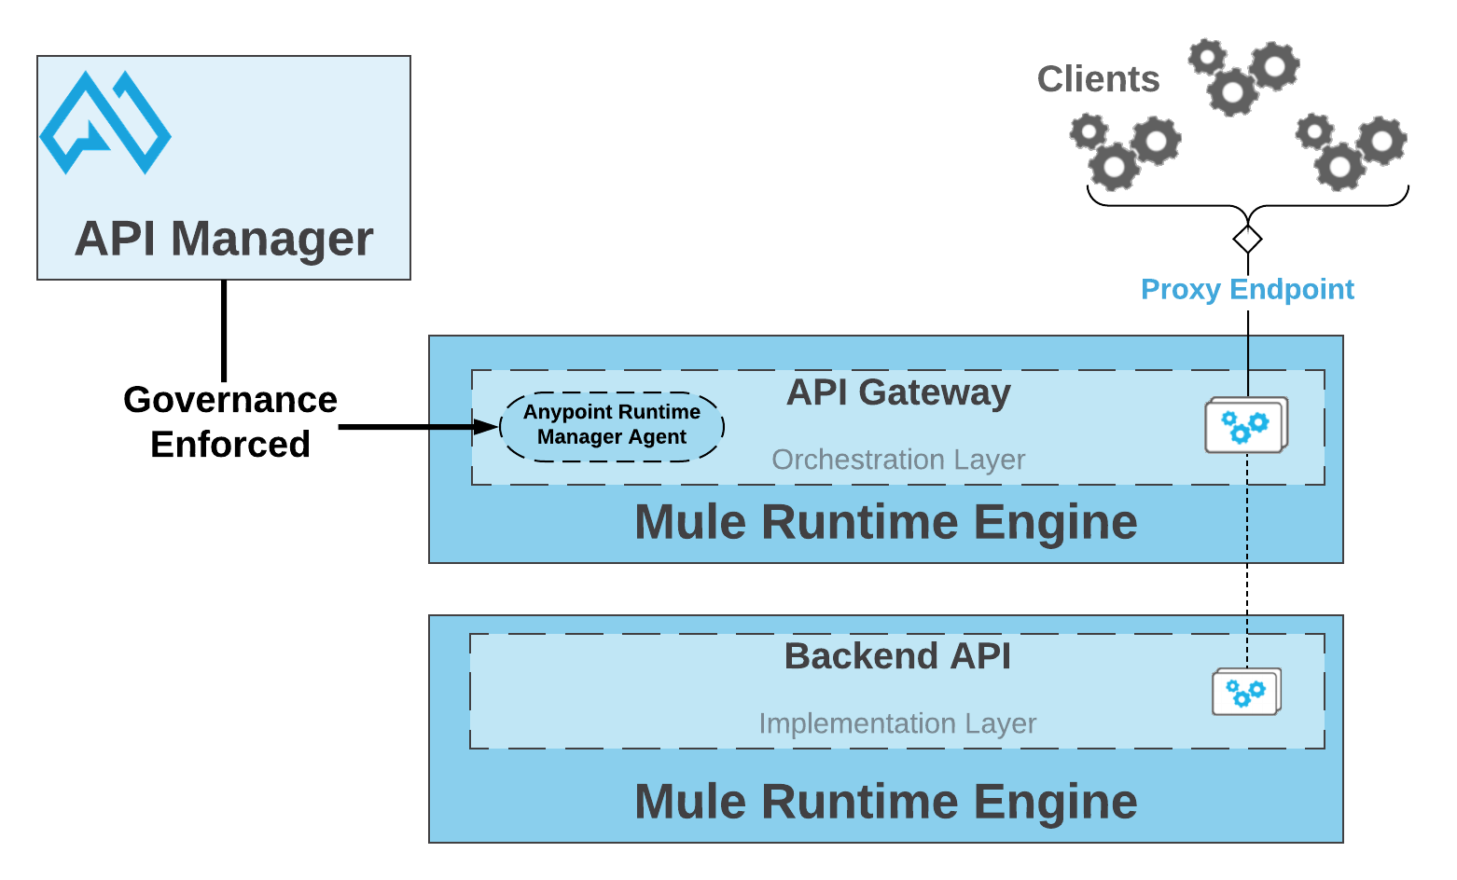

When you configure your API to be a Proxy Endpoint, Anypoint Platform allows you to download a preconfigured Mule application. If the application is deployed to a Mule Runtime and you are using the correct Platform Credentials, the API for the application will be automatically tracked by API Manager.

You do not need to know how to create a Mule application. You simply deploy the application to a correctly configured runtime.

If you would like to use HTTPS instead of HTTP, you can follow these steps:

- Import the autogenerated proxy into Anypoint Studio.
- Specify the certificates to be used.
- Deploy the application to Cloudhub or a runtime instance.

The proxies that can be downloaded from API Platform are a convenient tool to speed up your Application Network development.

Having said that, you are not restricted to using an autogenerated proxy. Any Mule application, provided with a correctly configured Auto-Discovery, can be used to leverage API Gateway capabilities.

Policies

Policies are the tool to apply orthogonal behavior to a whole API or to a resource of it.

You can create policies to enrich, filter, and control Incoming/Outgoing messages, and to apply a security layer on top of your API by, for example, enforcing token access to your API or whitelisting/blacklisting specific IP addresses.

API Gateway provides not only Out-Of-The-Box (OOTB) policies but an engine to create your own Custom Policies.

Analytics

When the API Gateway is connected to API Manager, you can monitor the usage of your registered API using API Analytics.

API Gateway reports API usage, including the detected policy violations.

Pointcut

API Gateway uses pointcuts to point a policy to the resource where it should be applied.

If you are enforcing a policy in API Manager, this policy uses pointcuts to determine the endpoints of your Mule application to which it should apply.

Just as the API autodiscovery element must be declared in your Mule application code, pointcuts are declared within the policies.

In Mule 4, pointcuts are invisible to the user and are only managed internally by the API Gateway and API Manager.

You can select the granularity of the pointcut when configuring most policies. You can find this configuration under the Method & Resource conditions of your policies.

The two available options are:

1. Apply configurations to all API methods & resources.

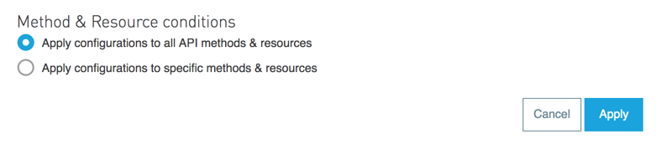
When selected, the API Pointcut matches every resource and method of your API. This means that the policy being applied will be executed for every request the HTTP Listener (linked with the API via Autodiscovery) receives.

2. Apply configurations to specific methods & resources.

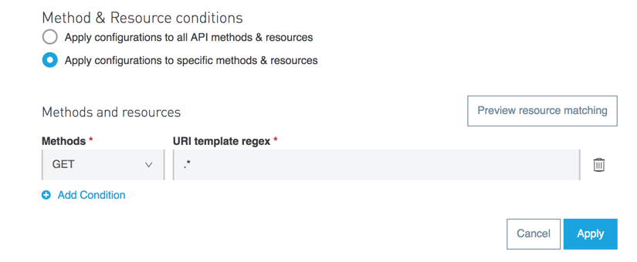
This defines a resource-level pointcut for your API. In this example, the policy is applied to the API only when the request method is a GET. You can optionally define a matching regex for the resource for further granularity.

Ports, IPs and hostnames whitelist

In your network, you may need to whitelist the hostnames and ports of various parts of Anypoint Platform to allow API Gateway capabilities of the runtime to communicate with the MuleSoft-managed online Anypoint Platform APIs and services.

The following table shows you the ports or IPs/hostnames to add to your whitelists to allow communication between the Runtime Manager Agent and the Runtime Manager console:

Plane | Host | Port
US | anypoint.mulesoft.com | 443
US | mule-manager.anypoint.mulesoft.com | 443
US | runtime-manager.anypoint.mulesoft.com | 443
US | analytics-ingest.anypoint.mulesoft.com | 443
US | arm-auth-proxy.prod.cloudhub.io | 443
US | data-authenticator.anypoint.mulesoft.com | 443
US | exchange-files.anypoint.mulesoft.com | 443
US | exchange2-asset-manager-kprod.s3.amazonaws.com | 443
EU | eu1.anypoint.mulesoft.com | 443
EU | mule-manager.eu1.anypoint.mulesoft.com | 443
EU | runtime-manager.eu1.anypoint.mulesoft.com | 443
EU | analytics-ingest.eu1.anypoint.mulesoft.com | 443
EU | arm-auth-proxy.prod-eu.cloudhub.io | 443
EU | data-authenticator.eu1.anypoint.mulesoft.com | 443
EU | exchange-files.eu1.anypoint.mulesoft.com | 443
EU | exchange2-asset-manager-kprod-eu.s3.eu-central-1.amazonaws.com | 443

